BUG HUNT 101 — Recon to Report
Target: OWASP Juice Shop (Local Lab)
Tool Used: Kali Linux, Burp Suite, Nmap
Project Type: Web Application Security Testing
Submitted by : Alex George.
Date: 17 Jan 2026

1. Introduction
This project “Bug Hunt 101 — Recon to Report” demonstrates a basic web application security testing workflow in a safe lab environment. The target application used is OWASP Juice Shop running locally. The testing process includes reconnaissance, vulnerability testing (XSS, SQL Injection, and IDOR), capturing evidence using Burp Suite, and preparing a final report.
2. Tools Used
- Kali Linux
- OWASP Juice Shop (Docker)
- Burp Suite Community Edition
- Nmap
- Web Browser (Firefox)
3. Lab Setup
The OWASP Juice Shop vulnerable web application was deployed locally using Docker on Kali Linux. Burp Suite was configured as an intercepting proxy to capture and analyze the HTTP requests and responses between the browser and the application.

1.Docker Enabiling and nmap scan
2. Enabiling Burpsuite
3. OWASP juice shop packet capturing

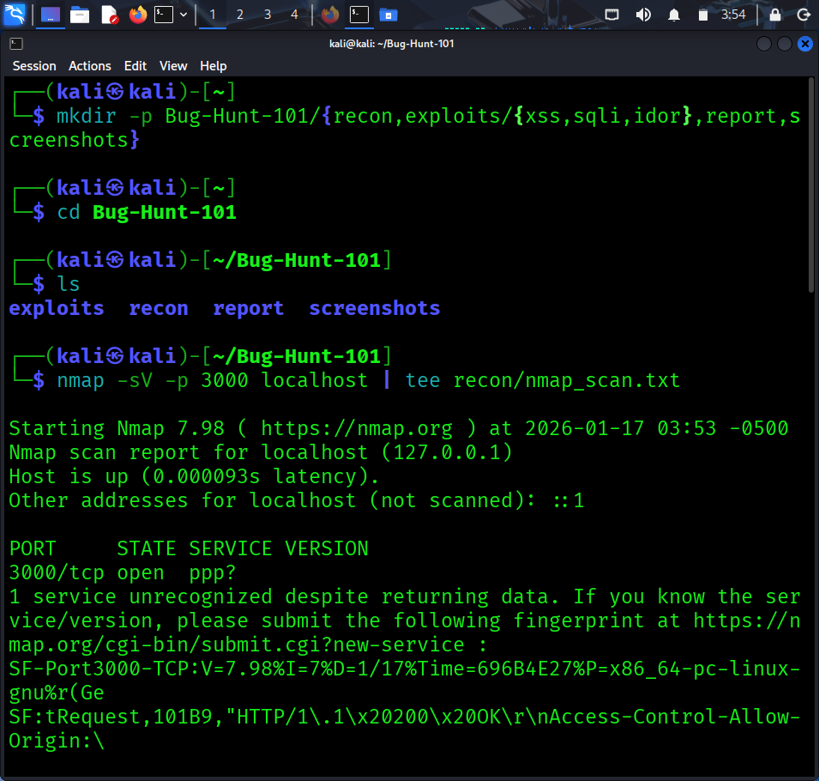
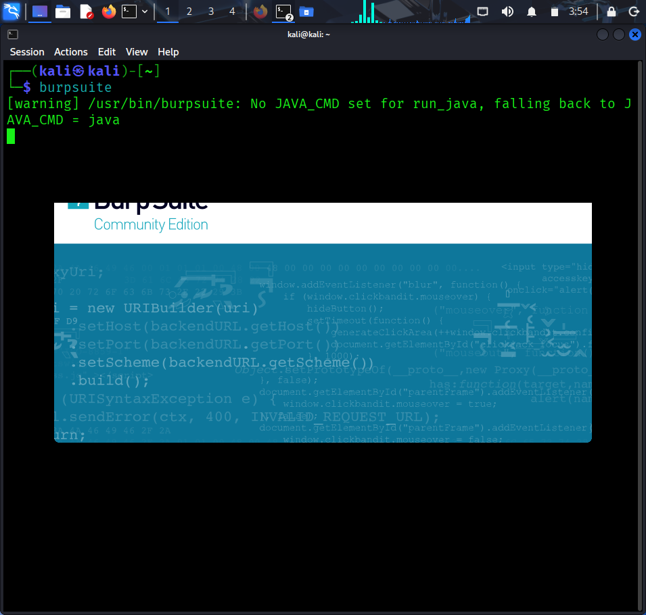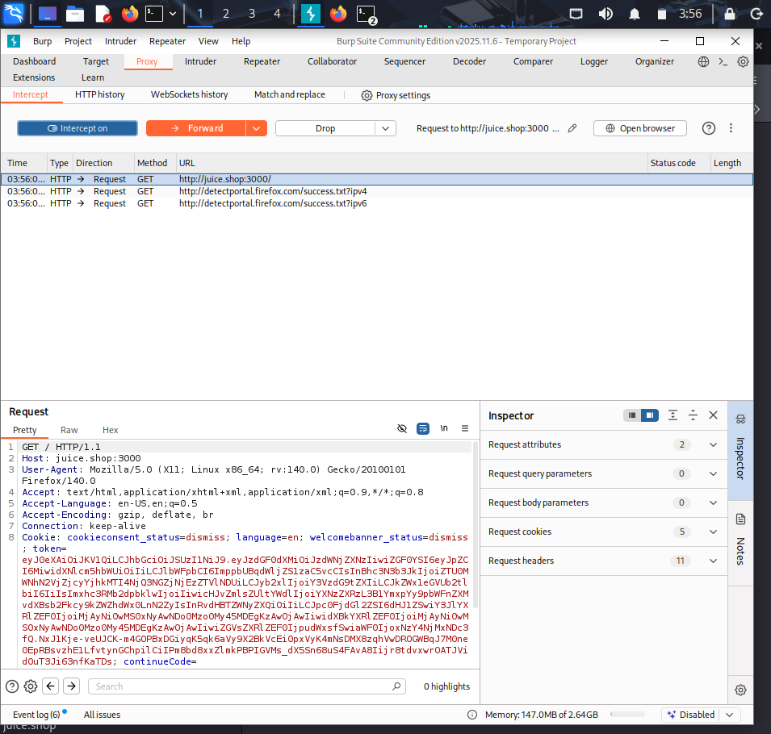

4. Reconnaissance (Nmap Scan)
Nmap was used to identify the open port and service version of the OWASP Juice Shop application running locally. The scan confirms that the application is accessible on port 3000 and helps in understanding the exposed service for further testing.
Command Used:
nmap -sV -p 3000 juice.shop
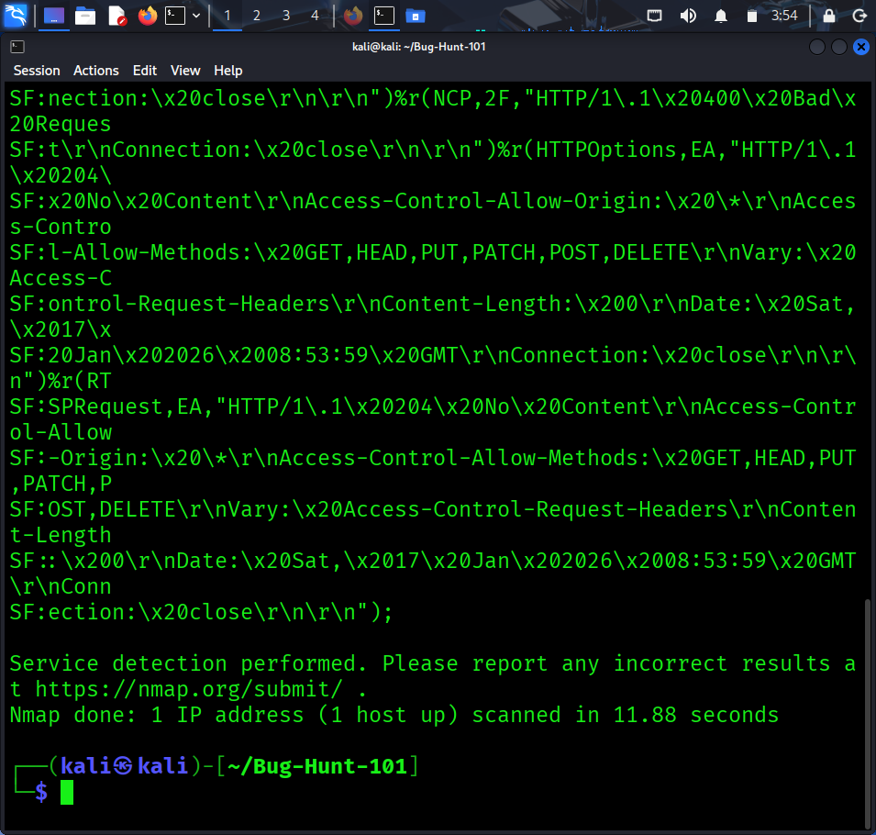
5. Vulnerability Testing
5.1 Cross Site Scripting (XSS) Testing
Cross Site Scripting (XSS) is a vulnerability where an attacker can inject malicious JavaScript code into a web application. This can lead to session hijacking, defacement, or stealing user information. In this project, XSS payloads were tested in input fields of OWASP Juice Shop using Burp Suite and the browser.
Payloads Tested:
<script>alert(1)</script>
<img src=x onerror=alert(1)>

1.Cross site scripting commang injection
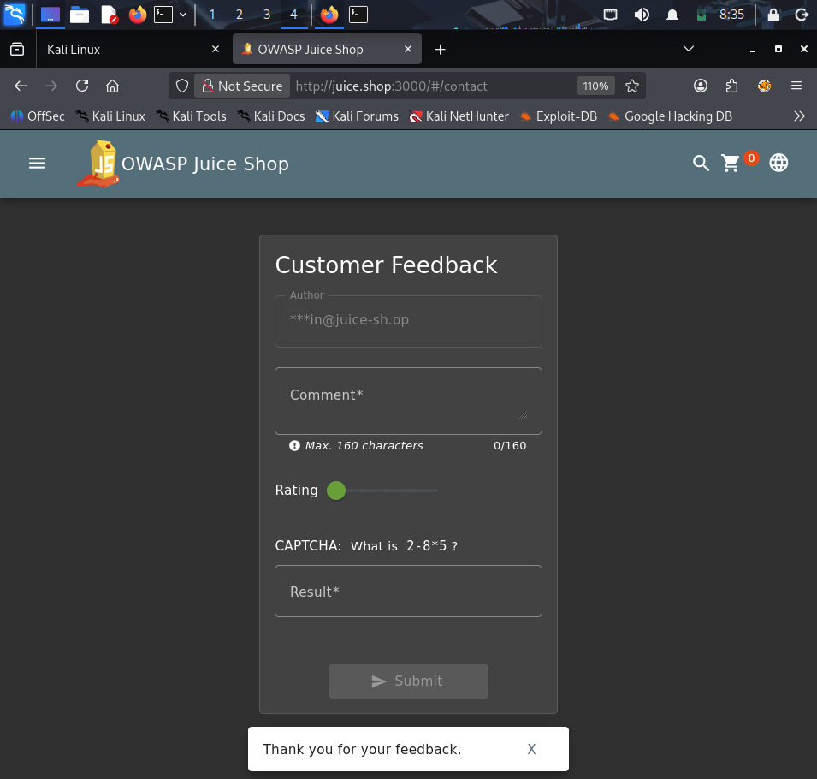

2. Cross site scripting response

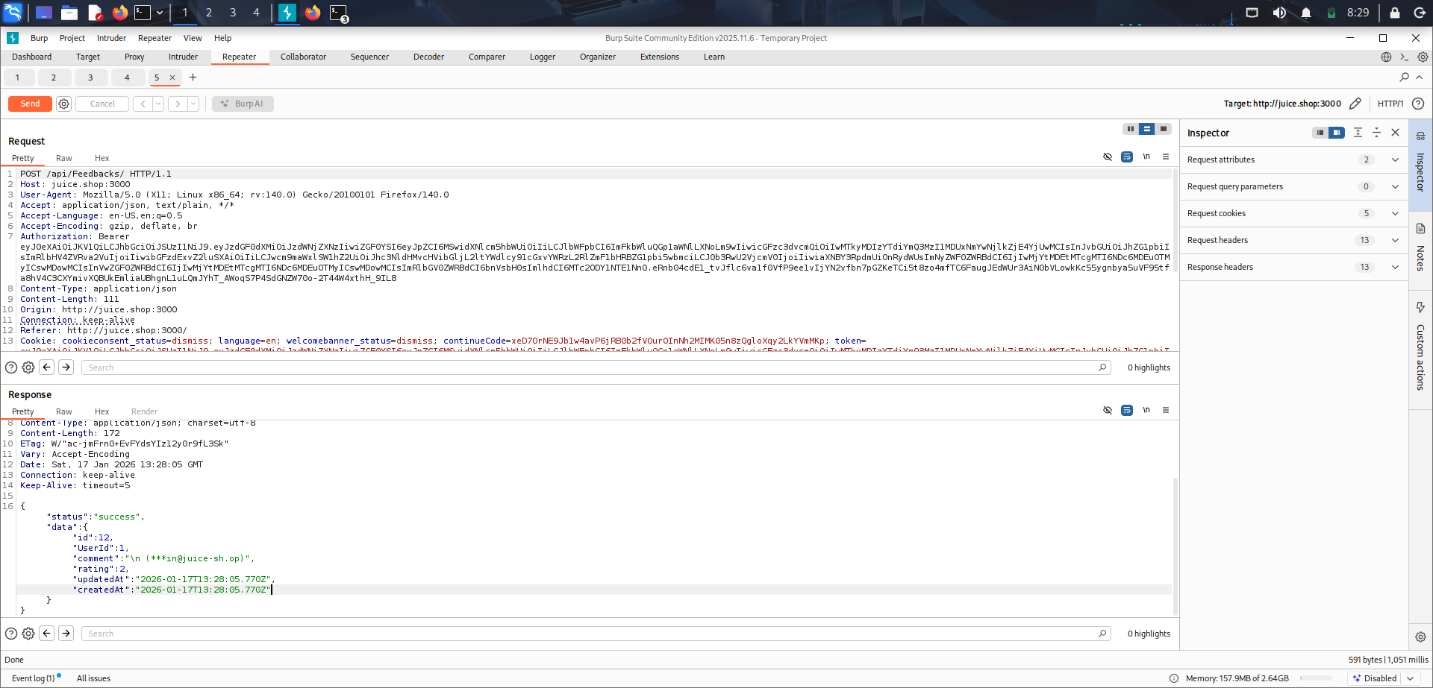

Result:
The application accepted the input request but the payload was sanitized/blocked and no alert popup was triggered. This indicates that XSS protection is present for the tested input.

5.2 SQL Injection (SQLi) Testing
SQL Injection is a vulnerability where an attacker can manipulate backend SQL queries by injecting malicious SQL code into input fields. This can lead to unauthorized login, database leakage, or data modification. In this project, SQL injection payloads were tested on the login functionality of OWASP Juice Shop.
Payload Tested:
' OR 1=1--
1.SQL injection Attacking on login Page
–––––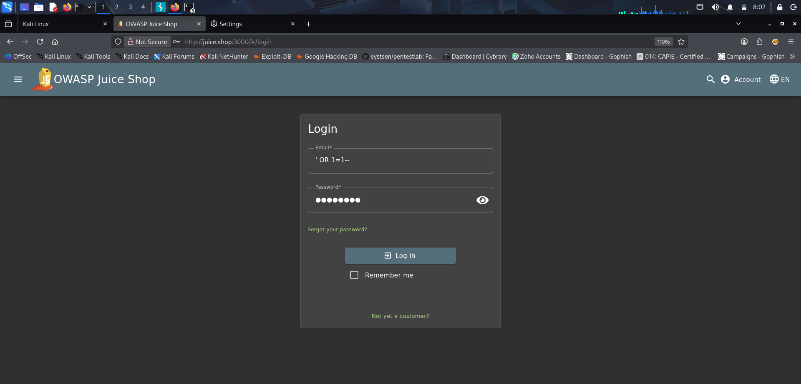
2. SQL injection Response
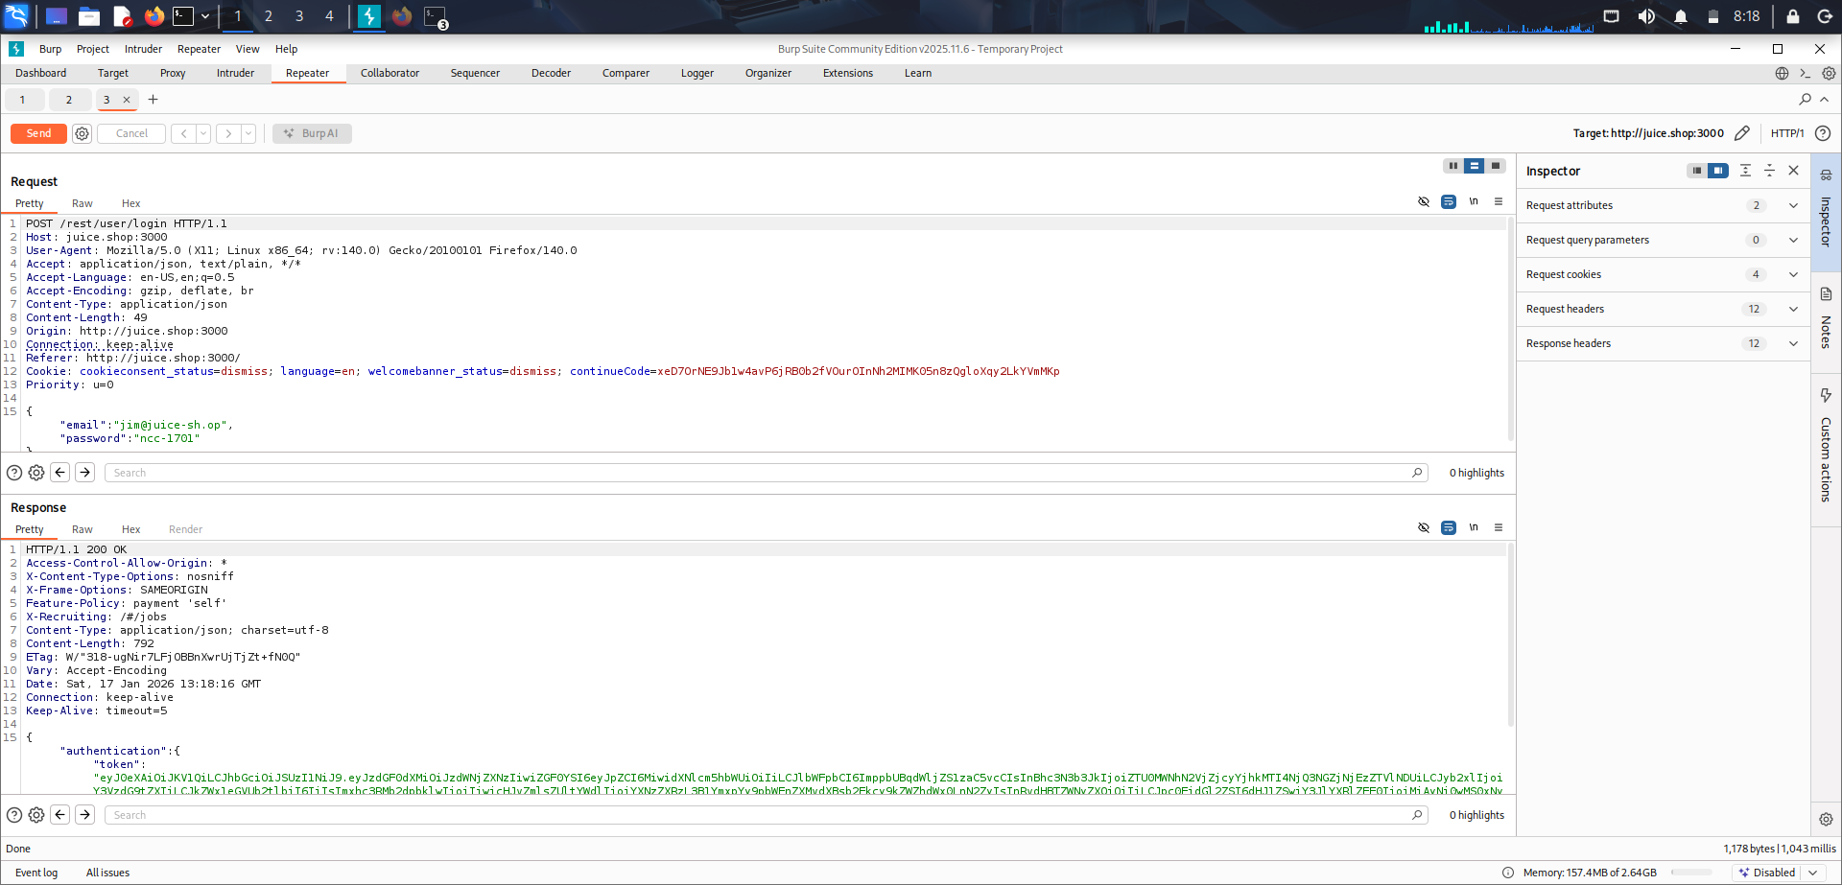

Result:
The login bypass was not successful and the server did not expose any SQL error message. The SQL injection attempt appears to be blocked or securely handled.

5.3 Insecure Direct Object Reference (IDOR) / Broken Access Control Testing
IDOR (Insecure Direct Object Reference) is a type of Broken Access Control vulnerability where an attacker can access another user’s data by modifying an object ID in the request (example: changing userId or addressId). In this project, the Address API request was captured using Burp Suite and analyzed to check whether sensitive address information is exposed.
Request Tested:
GET /api/Addresss HTTP/1.1
Host: juice.shop:3000
Authorization: Bearer <token>

IDOR 1: Capturing the Address API request using Burp Suite (HTTP History)
This screenshot shows the request to the address endpoint being captured in Burp Suite, which is used to analyze how user address data is fetched from the server.
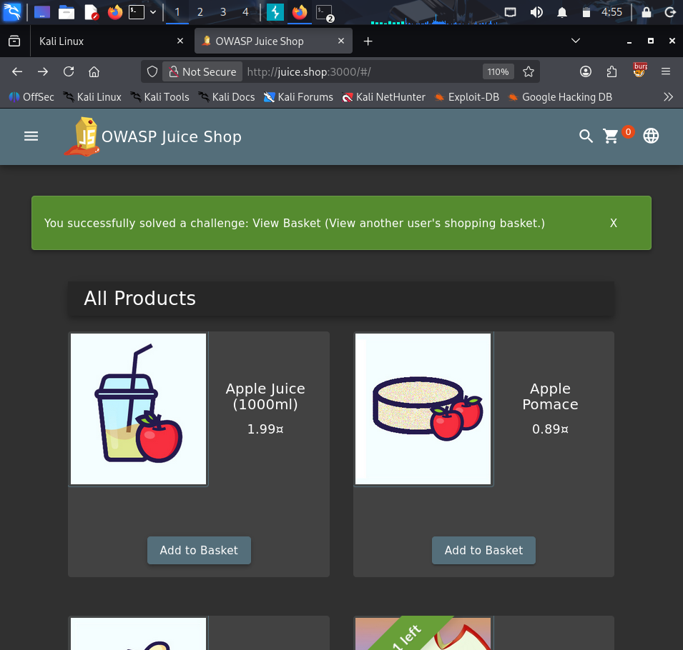
IDOR 2: Address API response containing user address details (PII exposure)
This screenshot shows the server response returning sensitive fields such as full name, mobile number, street address, and location details. This indicates excessive data exposure in the API response.
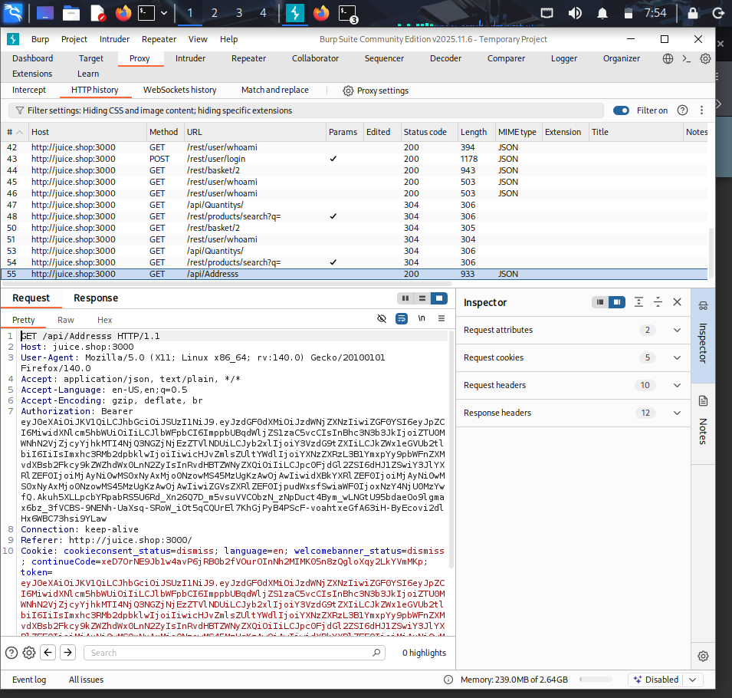

IDOR 3: Repeater-based analysis of the Address API response in Burp Suite
This screenshot shows the same request being tested in Burp Repeater to validate the response content and confirm that sensitive information can be retrieved through direct API calls.
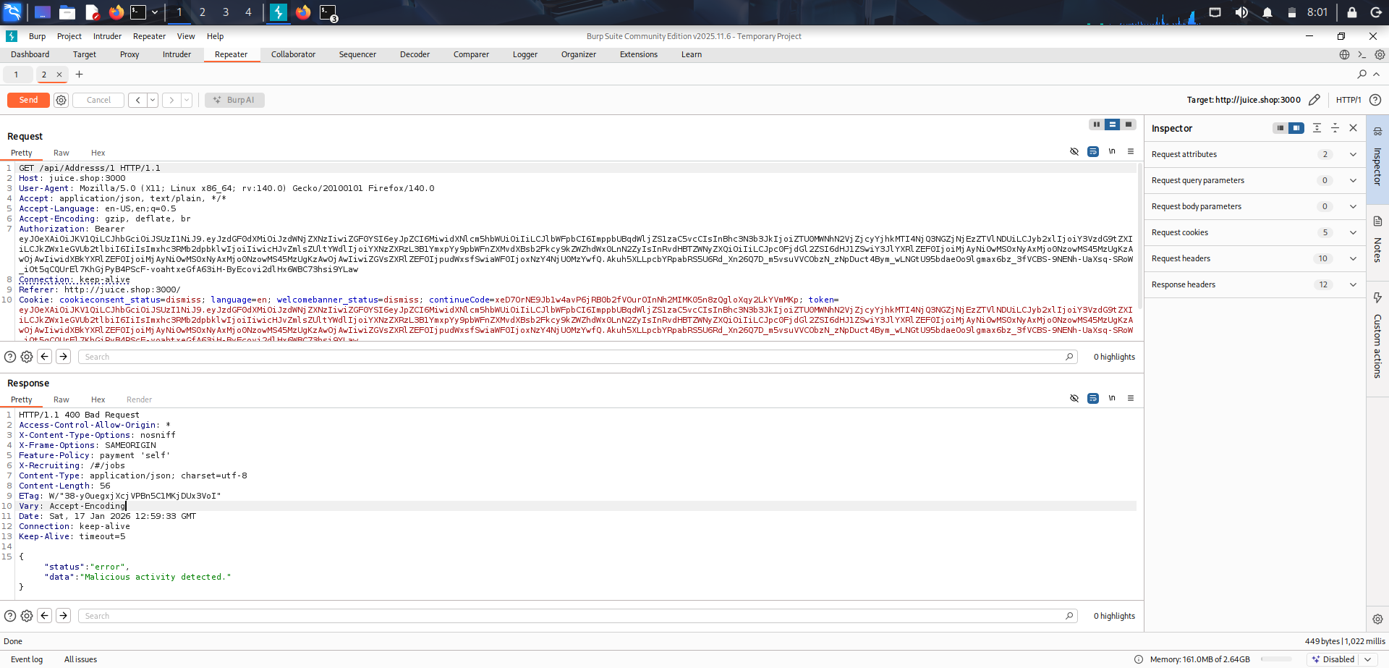
Result:
The API returned sensitive address details such as full name, mobile number, and full address information in the response. This is considered Excessive Data Exposure / Sensitive Data Exposure, and it may impact user privacy.

6. Findings Summary
This project successfully demonstrated the complete workflow of recon-to-report in a safe lab environment. Multiple vulnerability categories were tested using Burp Suite and the browser. The Address API response was observed to expose sensitive personal details, which can lead to privacy risks. Other vulnerabilities like XSS and SQL injection were tested but did not result in successful exploitation in the tested areas.

Vulnerability | Status | Severity
XSS | Tested (Sanitized/Blocked) | Informational
SQL Injection | Tested (No bypass) | Informational
Excessive Data Exposure (Address API) | Found | Medium

7. Conclusion
In conclusion, OWASP Juice Shop provided a realistic environment to understand how web vulnerabilities are tested and documented. Reconnaissance was performed using Nmap, traffic analysis was done using Burp Suite, and multiple attack types were tested. The report includes proof screenshots and clear reproduction steps, demonstrating a beginner-level bug hunting and reporting approach

Task completed list

